**Food Delivery App:**

Let us develop a food delivery application, enabling customers to place orders and administrators to manage items and order statuses efficiently. The admin panel should auto-refresh to display the latest orders and automatically reject orders if not processed within a set time frame. The application will be divided into two main modules:

**Customer Module:**

* **Registration/Login:** Customers can create accounts and authenticate.
* **Place Order:** Authenticated customers can browse available items and place orders and also view order history.

**Admin Module – Order Management:**

* **Order Listing:** The admin sees orders separated into three sections: Pending, Accepted, and Rejected. Only orders from the current date are shown.
* **Auto Refresh:** The page auto-refreshes (using a meta tag or JavaScript) to always display the latest orders.
* **Order Acceptance/Rejection:** The admin can manually accept or reject orders which are in pending state.
* **Auto-Rejection:** If an order is not accepted within five minutes, a background check (invoked when the admin page loads) automatically marks it as Rejected.

Let us first understand the application work flow and the different pages and then we will develop this application step by step using ASP.NET Core MVC, Entity Framework Core Code First Approach with SQL Server Database, and also use the Auto Page Refresh Functionality.

**Home Page or Landing Page:**

This page serves as the public face of your application. It introduces the food delivery service, highlights key benefits, and often includes calls-to-action (such as Order Now or Sign Up) to guide users into the app.

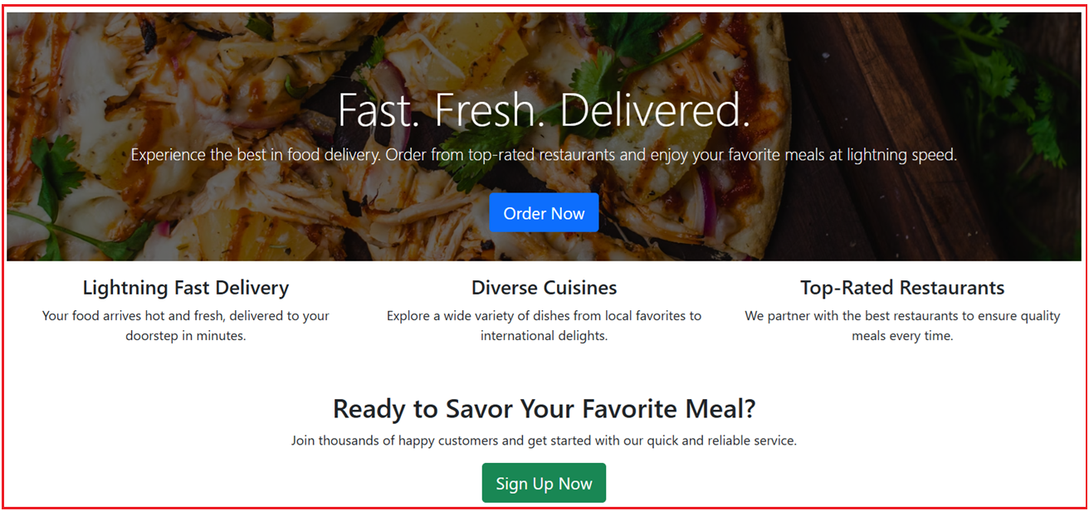

**Customer Registration Page:**

New users use this page to sign up for an account. It gathers essential information like name, email, and password, enabling customers to create a secure profile for future logins and orders.

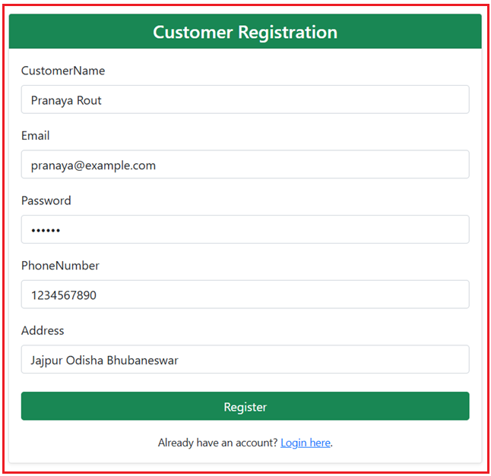

**Customer Login Page:**

Existing customers use this page to sign in. Once logged in, users can access ordering features, view order history, and manage their account details.

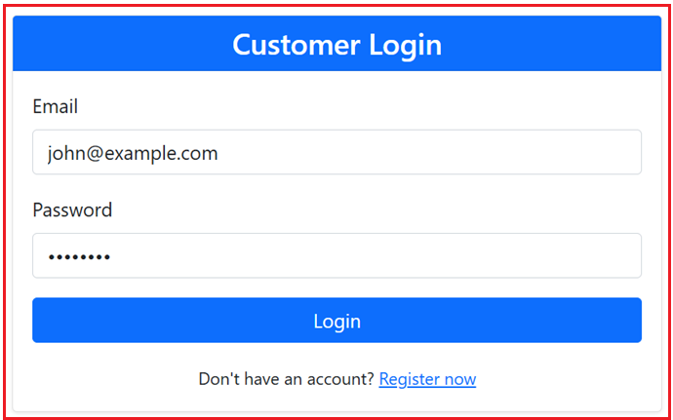

**Customer Order Placing Page:**

Provides the interface for customers to browse available food items and place orders. Displays a list or grid of items (often with images, names, prices, and availability). Customers can select quantities and submit an order, which then gets recorded in the system.

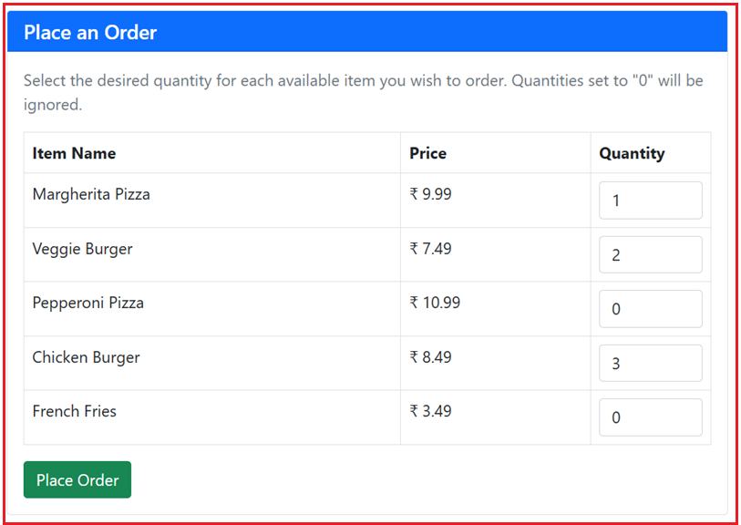

**Customer Order History Page:**

This page displays a record of previous orders. Customers can review details such as order status, delivery time, and total cost, which helps them track their past interactions with the service.

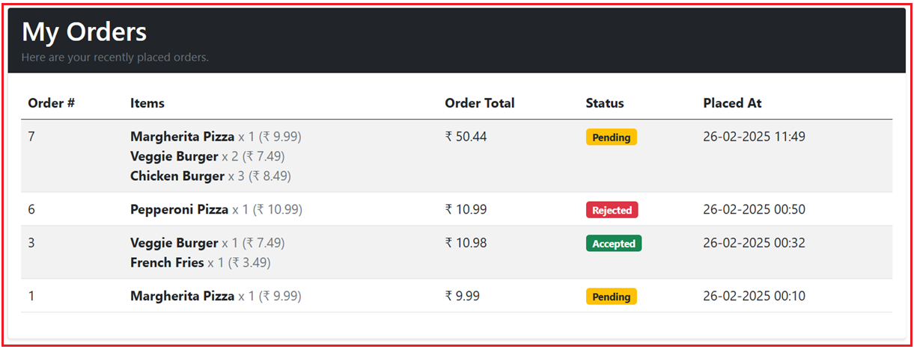

**Admin Login Page:**

Administrators use this secure page to log into the backend system. This ensures that only authorized personnel can manage orders and products.

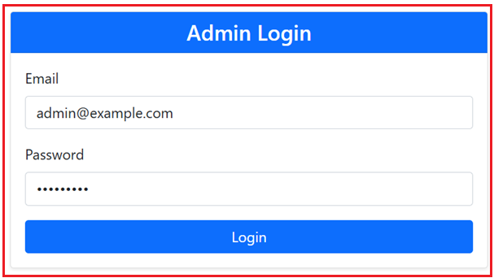

**Admin Product or Item Dashboard Page:**

On this dashboard, administrators can view and manage the list of available food items. It includes details like item name, description, price, and availability, allowing for quick inventory adjustments and oversight.

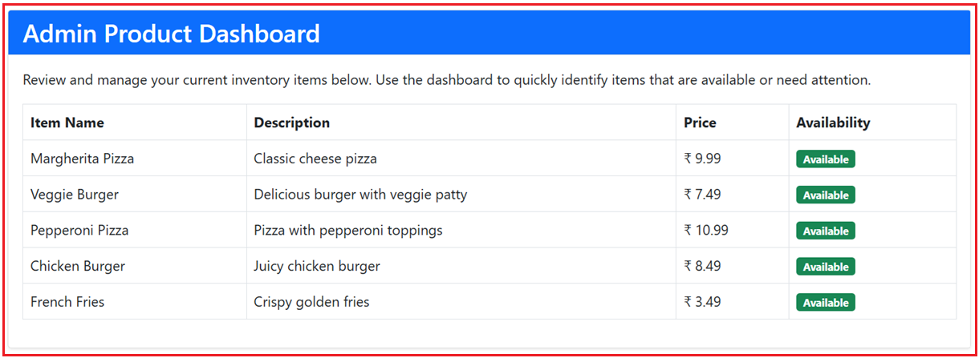

**Admin Order Manage Page (Pending Order Tab):**

This tab in the Orders page displays all orders that are awaiting action. Admins can review pending orders and manually accept or reject them. There is also an automatic mechanism to reject orders if they aren’t processed within five minutes.

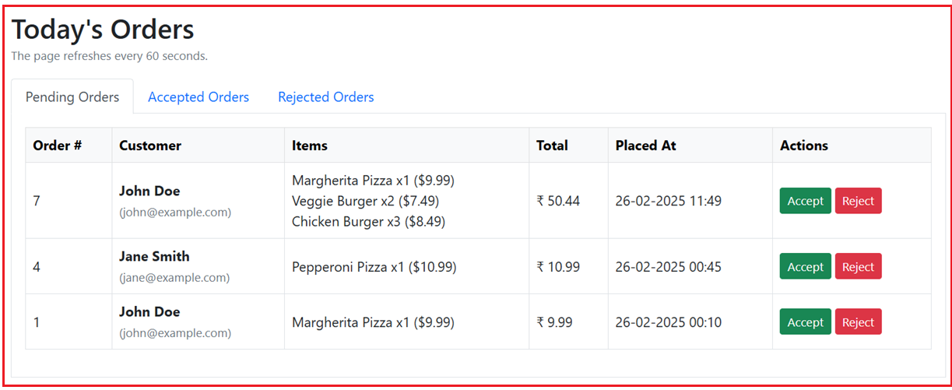

**Admin Order Manage Page (Accepted Order Tab):**

Here, administrators can view all orders that have been accepted. This helps in tracking which orders are in progress and ensuring timely processing and delivery.

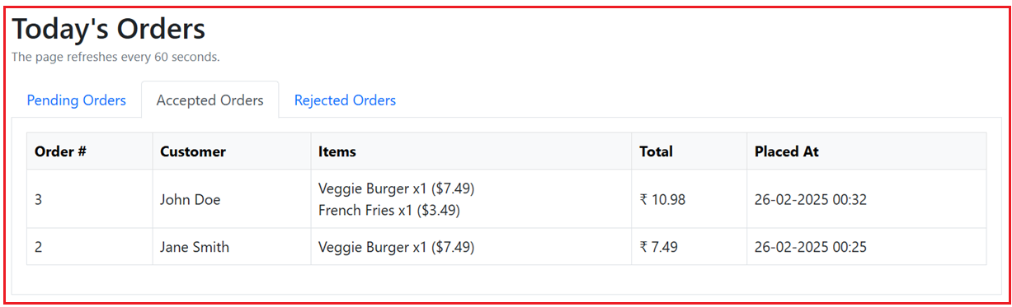

**Admin Order Manage Page (Rejected Order Tab):**

This page lists orders that have been rejected, whether manually by an administrator or automatically due to processing delays. It provides a clear record of orders that did not proceed.

